ASSIGNMENT NO. 4: Working with Multiple Tables and Joins
Questions:
Q1) Create a MySQL database named CollegeDB and create the following tables:
Student Table
Column Name | Data Type | Constraint
StudentID | INT | PRIMARY KEY
StudentName | VARCHAR(50)
City | VARCHAR(30)

Course Table
Column Name | Data Type | Constraint
CourseID | INT | PRIMARY KEY
CourseName | VARCHAR(50)
Fees | DECIMAL(10,2)

Enrollment Table
Column Name | Data Type | Constraint
EnrollmentID | INT | PRIMARY KEY
StudentID | INT | FOREIGN KEY
CourseID | INT | FOREIGN KEY
EnrollmentDate | DATE
Query-
CREATE DATABASE CollegeDB; USE CollegeDB;
CREATE TABLE Student (StudentID INT PRIMARY KEY,
CREATE TABLE Student (StudentID INT PRIMARY KEY,
StudentName VARCHAR(50), City VARCHAR(30));
CREATE TABLE Course (CourseID INT PRIMARY KEY,
CourseName VARCHAR(50), Fees DECIMAL(10,2));
CREATE TABLE Enrollment (
EnrollmentID INT PRIMARY KEY,
StudentID INT,
CourseID INT,
EnrollmentDate DATE,
FOREIGN KEY (StudentID) REFERENCES Student(StudentID),
FOREIGN KEY (CourseID) REFERENCES Course(
CourseID));

Output-
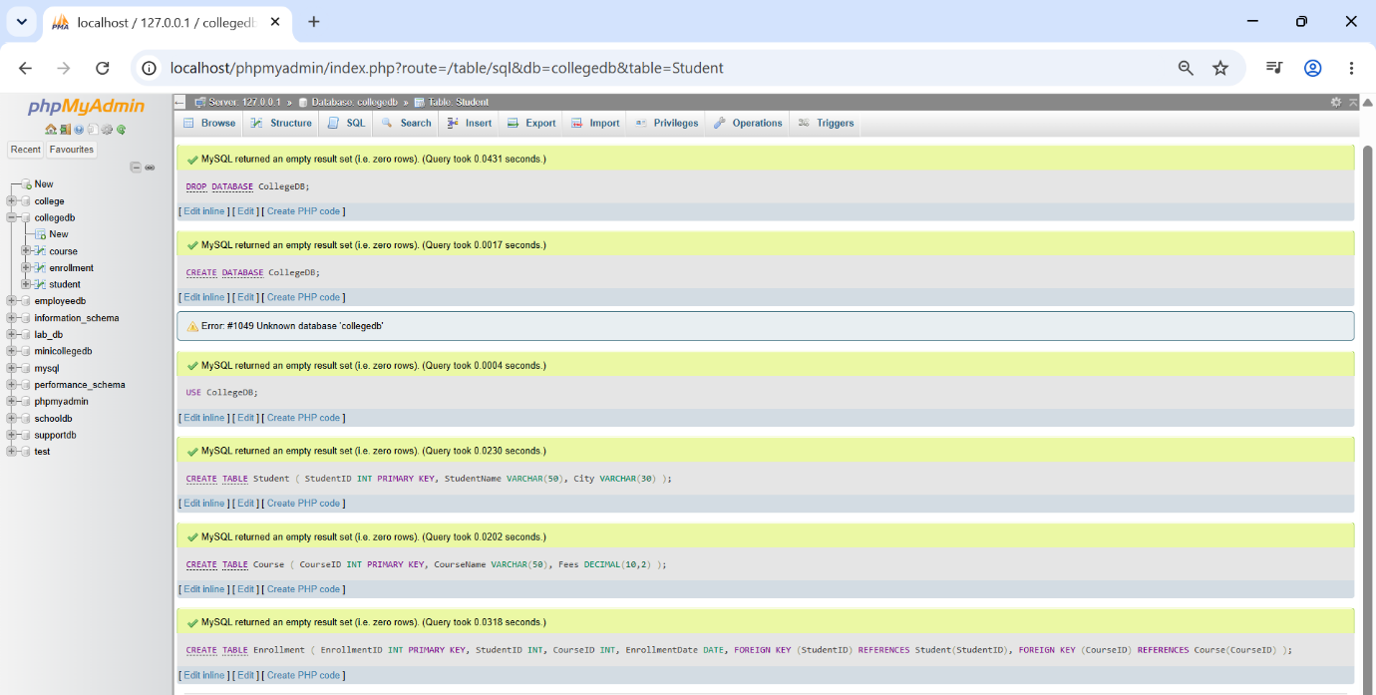
Q2) Insert at least 6 records into the Student table, 4 records into the Course table, and 5 records into the Enrollment table.
Make sure:
Requirement
At least one student should not have enrollment
At least one course should not have any enrolled student

Query-
INSERT INTO Student VALUES (1, 'Alice', 'NY'),
(2, 'Bob', 'LA'), (3,'Charlie','SF'),
(4, 'Dave', 'CHI'), (5, 'Eve', 'MIA'),
(6, 'Frank', 'SEA');
INSERT INTO Course VALUES
(101, 'Math',26,500.00), (101, 'Math',500.00),
(102,'Science',600.00), (103, 'Art',300.00),
(104, 'History',400.00);
INSERT INTO Enrollment VALUES
(1001,1,101, '2023-01-01'),
(1002,2, 101, '2023-01-02'),
(1003,3,102, '2023-01-03'),
(1004,4,103, '2023-01-04'),
(1005,5,103, '2023-01-05');
Output-
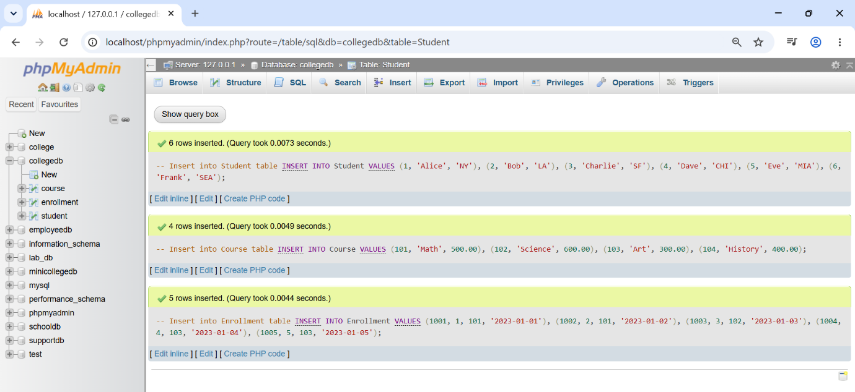
Q3) Write a MySQL query using INNER JOIN to display students who have enrolled in
courses.
The output should include:
Column
StudentID
StudentName
CourseID
EnrollmentDate

Query-
SELECT Student. StudentID,
Student. StudentName,
Enrollment. CourseID,
Enrollment.EnrollmentDate
FROM Student
INNER JOIN Enrollment ON
Student.StudentID =
Enrollment.StudentID;

Output-
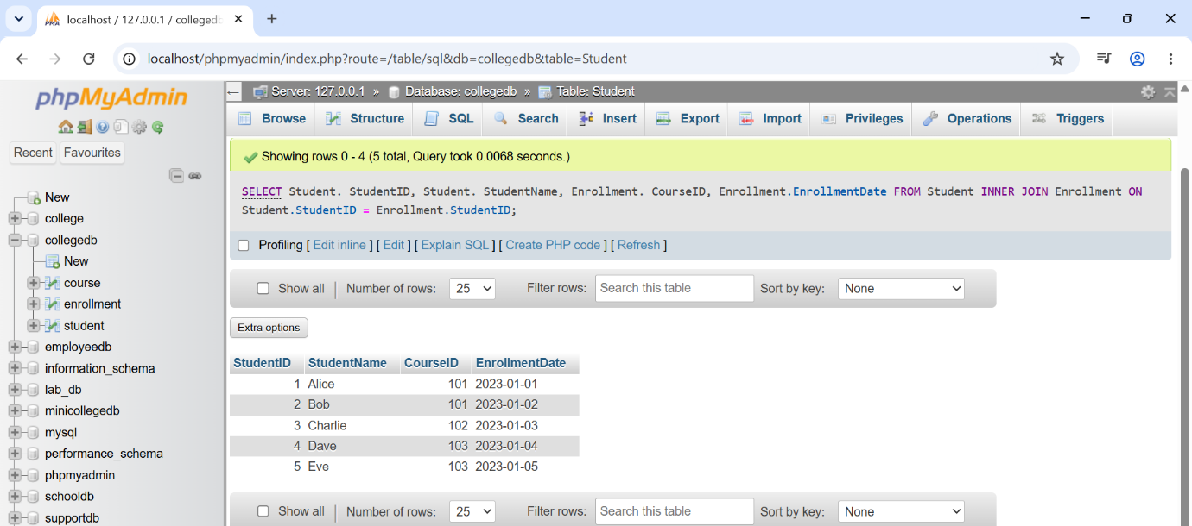
Q4) Write a MySQL query to display student name, city, course name, fees, and
enrollment date using multiple tables.
Use:
Tables Required
Student
Course
Enrollment
Query-
SELECT Student.StudentName,
Student.City,
Course.CourseName,
Course. Fees,
Enrollment.EnrollmentDate
FROM Student
JOIN Enrollment ON
Student. StudentID =
Enrollment.StudentID
JOIN Course ON Enrollment. CourseID
= Course. CourseID;

Output-
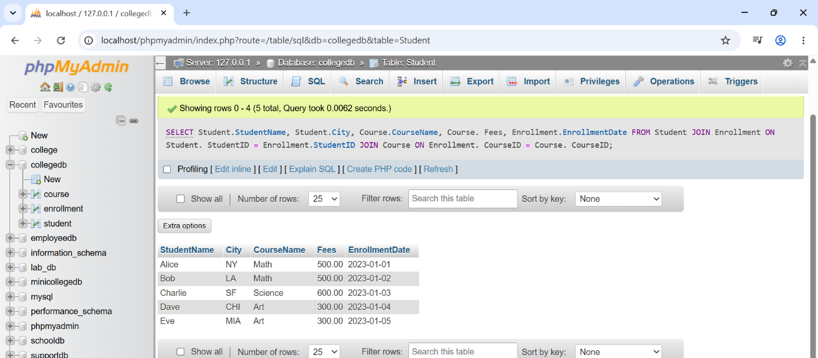
Q5) Write a MySQL query using LEFT JOIN to display all students, including those who
have not enrolled in any course.
The output should include:
Column
StudentID
StudentName
City
CourseID
EnrollmentDate

Query-
SELECT Student.StudentID,
Student.StudentName,
Student.City,
Enrollment. CourseID,
Enrollment.EnrollmentDate
FROM
Student
LEFT JOIN Enrollment
ON Student.StudentID = Enrollment.StudentID;
Output-
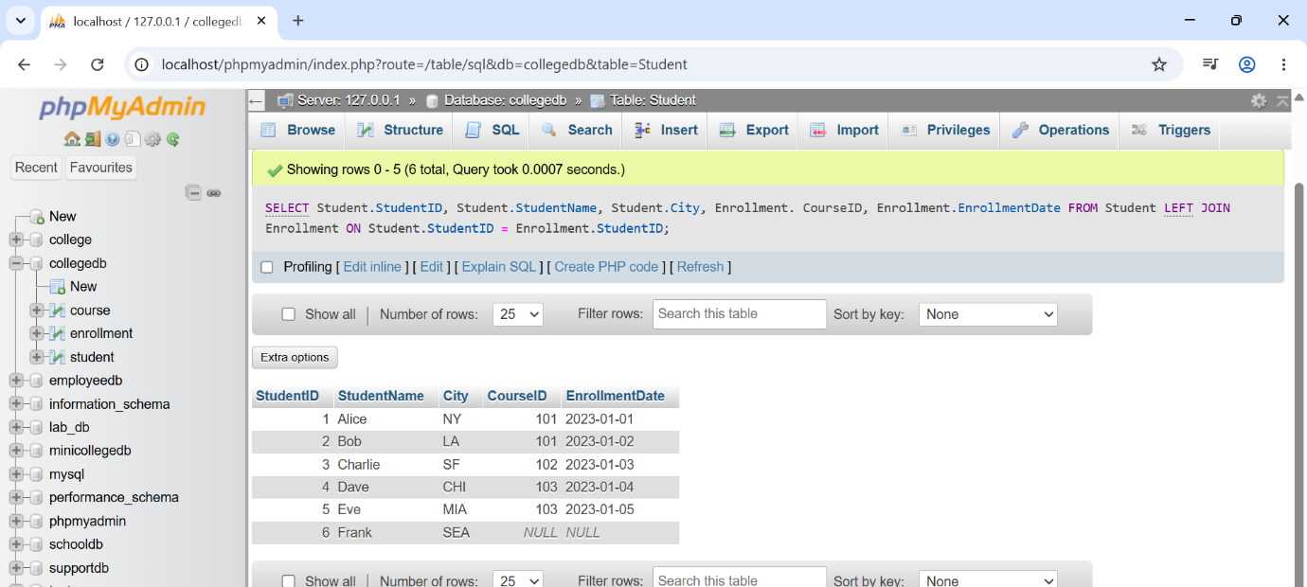
Q6) Write a MySQL query using RIGHT JOIN to display all courses, including courses
that have no enrolled students.
The output should include:
Column
StudentName
CourseID
CourseName
Fees

Query-
SELECT Student.StudentName,
Course.CourseID,
Course.CourseName,
Course.Fees
FROM Student
JOIN Enrollment ON
Student.StudentID = Enrollment.StudentID
RIGHT JOIN Course ON
Enrollment.CourseID = Course.CourseID;

Output-
